

American International University-Bangladesh (AIUB)  
**Department of Computer Science  
Faculty of Science & Technology (FST)**

**Project name: Ukeel**

A Software Engineering Project Submitted

By

|  |  |  |  |  |
| --- | --- | --- | --- | --- |
| **Semester: Summer_21_22** | | **Section:** | **Group Number:** | |
| SN | Student Name | Student ID | Contribution (CO1+CO2) | Individual Marks |
| 1 | MD SALMAN HOSSAIN | 20-43954-2 | 35% |  |
| 2 | SUMIT CHAKRABORTY | 20-43472-1 | 35% |  |
| 3 | MD. TANVIR ALAM NILOY | 19-39422-1 | 30% |  |

# PROJECT PROPOSAL

## Background to the Problem

We must hire lawyers for various legal works. For example, car accident cases, land issues, taxation etc. But in Bangladesh it is very difficult to hire lawyers. We must go to the courts or chambers of the lawyers to hire them. But it comes with very high fees and sometimes there is a shortage of time and lawyers also. For that reason, sometimes poor people cannot afford it. This problem is so important to consider because there are a lot of hassles in legal work in Bangladesh. It costs people valuable time and money. Sometimes due to ignorance and not consulting a proper lawyer people have to deal with many problems. Often, they fall victim to unwanted circumstances.

## Solution to the Problem

Project thesis/ objective: We can hire lawyers easily. This project will save time for our consumers and give them a proper hiring solution. Furthermore, it will reduce the cost of hiring. Ukeel will be an online legal service app where users can get 24/7 video consultations from lawyers. Ukeel will use 256-bit encryption to secure the video consultation. Users can also keep their previous consultation history. A lawyer can join the platform using our simple boarding process. We will verify every lawyer to make sure only authorized lawyers are providing consultation using our updated solutions. Because this platform will save people’s time and money. In our solution, users will search for a lawyer by specialty and make payments online and pay fees required by the lawyer. Then lawyer makes a video call to do the consultation. This platform will generate revenue from the users. We will develop an application to provide the ultimate solution of social, safety and legal issues of the society. Our target customer will be in the age group of 18 to 40 and the need of the service has no age limits. When we are looking for a lawyer. We don't really get the exact one we need instantly so we have to search for it and get some hassle for that and here the Ukeel application comes from. It really helps to find a well-mannered certified capable lawyer for the consumer and that system makes daily life easier. and that's called the development of a society when we modernize the system. As we are working in Bangladesh, there is no existing solution for that, and we are the first one to come with this kind of application to bring people modernized and make their work easier. In the future we can also work with different varieties of laws.

## Requirements

1. Sign up

* The software shall allow customers to sign up with their username, password, email, phone number, residential address.
* The software shall allow lawyers to sign up with their username, password, email, phone number, residential address, type of lawyer, certificates, nid.
* The sign-up credentials (username, password, email etc) will be stored in databases.

Priority level: High

Precondition: nothing

1. Login

* The software shall allow customers to login with their given username or email or phone number and password.
* The software shall allow lawyers to login with their username, or email and phone number.
* The login credentials (username and password) will be verified with database records.
* If the login successful, the home page of the user account will be displayed.
* If the username and/or password has been inserted wrong, the random verification code
* will be generated and sent to the user’s email address by the system to retry login.
* If the number of login attempt exceed its limit (3 times), the system shall block the user account login for thirty minutes.

Priority level: High

Precondition: User have valid id and password

1. Search

* The software shall allow users to search and filter for verified lawyer by specialty, experience ratings, profile, price, available online now.
* The searching keywords will have to match with the database records.
* If the keywords successfully match with database records, then the profiles will be displayed.
* Users can search without login or sign up.

Priority level: Medium

Precondition: nothing

1. See profile

* The software shall allow users to see profile of the lawyer.
* To see the full profile customer must have an account.
* If the customer using this app without login, then they have to login to see the profile.

Priority level: High

Precondition: login

1. Live Customer Support (Chatting, Calling)

Functional Requirement

1. An auto reply will be given by a bot to the customer after their first message.
2. Our employee will receive a notification of the customer’s message.
3. We will contact to each other by chatting.
4. Customer will share their problems through chatting.
5. If the matter does not solve then the customer can call.

Priority Level: Medium

Precondition: Login

1. Payment system

 1.1 A customer will allow to pay in 3 different types of way Card / Bank / mobile banking  
 1.2 A customer will have to insert an account number and they will verify the type of card and validations of the account number   
 1.3 The system will cut the commissions of 2%.   
 1.4 after successfully insert the system will calculate the whole consuming amount and make a total cost count.  
 1.5 the customer will able to see the print button and the data will store in database   
 1.6 after that the program will archived.   
   
 Priority level: High  
 preconditions: User will have valid user id, account number and special   
 cross reference: 1.1,1.3,1.5

Features

* A user(customer) can create an account.
* A user(customer) can login and signup.
* A user can search lawyers by their types.
* A user can see the lawyer status/profile.
* A user can see the availability of the lawyers.
* A user can take an appointment through calls.
* A user can attach documents or photos to help the consultation.
* Appointment reminder.
* Appointment canceling.
* A lawyer can update his valid profile.
* A lawyer can reject an appointment with valid reason.
* A lawyer can set their own appointment fees.
* A lawyer can set their payment method, either it is card payment or mobile banking or cash.
* A lawyer can check their earnings reports.
* Payment withdrawals for lawyers.
* User payment.

## Diagram

**Use Case Diagram:**

MD. TANVIR ALAM NILOY

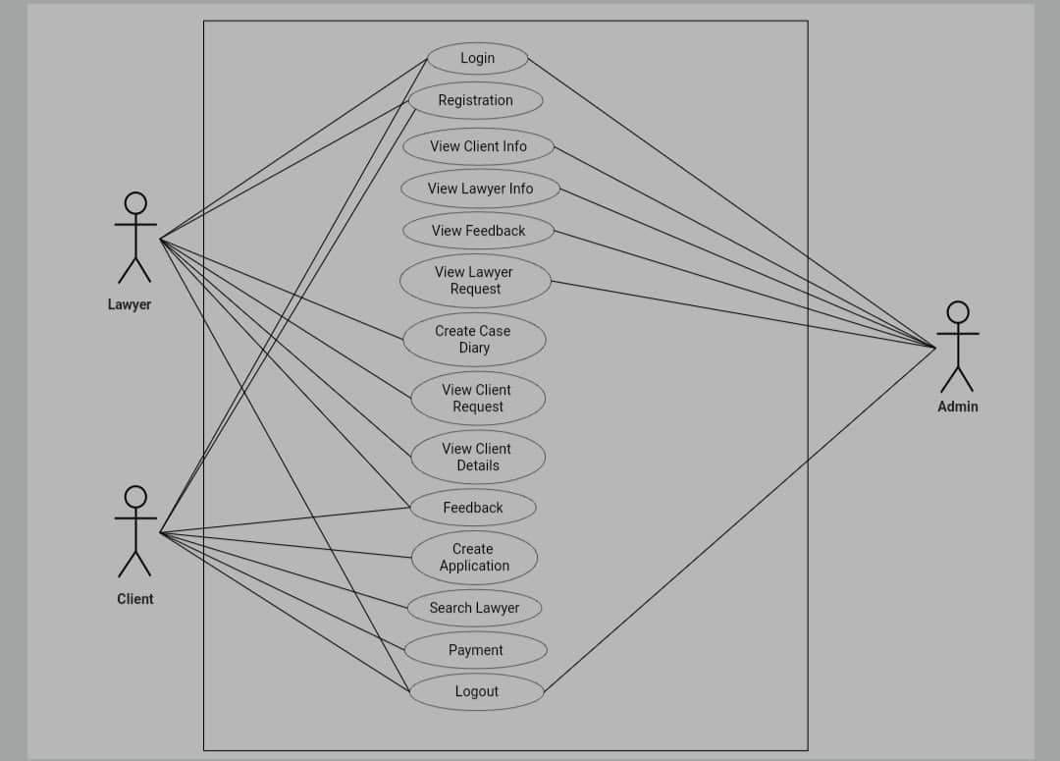

**State Chart Diagram:**

## SEQUENCE DIAGRAM

1 Login

### Figure 3. 24: Login

3.4.2 Registration

### Figure 3. 25: Registration

3.4.3 View lawyer & user information (Admin)

### Figure 3. 26: View lawyer & user information (Admin)

3.4.4 lawyer request

### Figure 3. 27: lawyer request

3.4.5 Delete Lawyer & user ID

### Figure 3. 28: Delete Lawyer & user ID

3.4.6 view Feedback

### Figure 3. 29: view Feedback

3.4.7 Create a case dairy

### Figure 3. 30: Create a case dairy

3.4.8 View Case dairy

### Figure 3. 31: View Case dairy

3.4.9 Case dairy edit

### Figure 3. 32: Case dairy edit

3.4.10 Case dairy delete

### Figure 3. 33: Case dairy delete

3.4.11 View the user request

### Figure 3. 34: View the user request

3.4.12 View the user

### Figure 3. 35: View the user

3.4.13 Feedback

### Figure 3. 36: Feedback

3.4.14 Create application

### Figure 3. 37: Create application

3.4.15 Application Update

### Figure 3. 38: Application Update

3.4.16 Application delete

### Figure 3. 39: Application delete

3.4.17 View application

### Figure 3. 40: View application

3.4.18 User feedback

Figure 3. 41: User feedback

**Class Diagram:**

MD SALMAN HOSSAIN

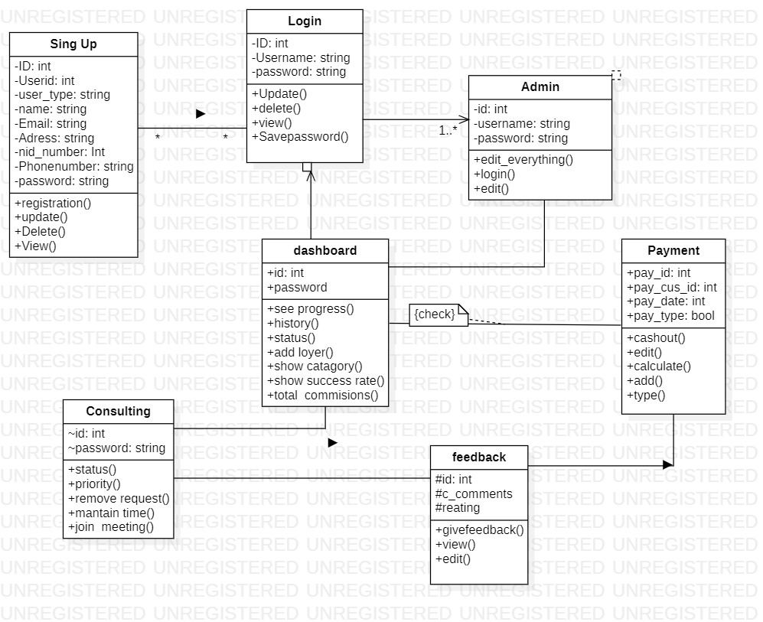

**Activity Diagram:**

Sumit Chakraborty

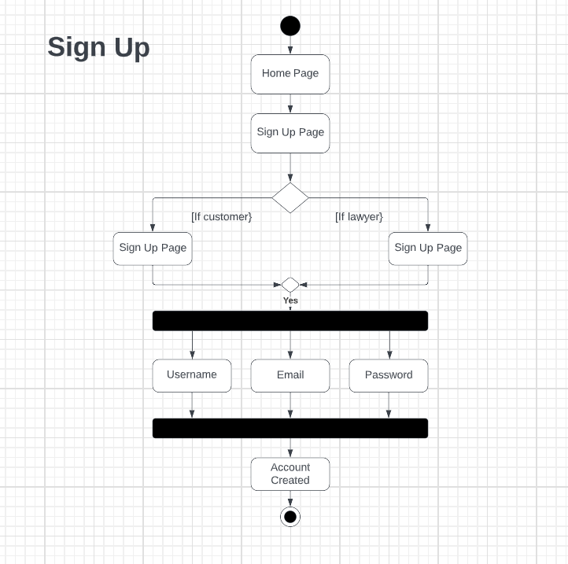

Meraj Ur Rahman

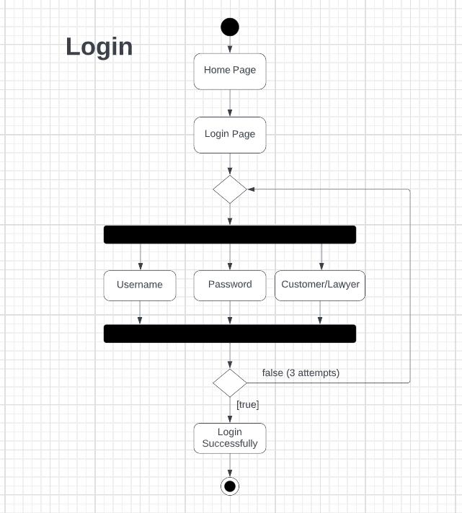

Search:

Meraj UR Rahman

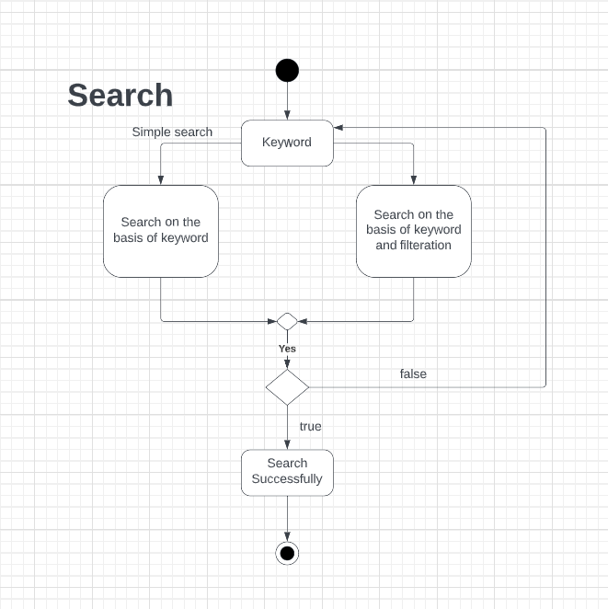

Payment:  
Sumit Chakraborty

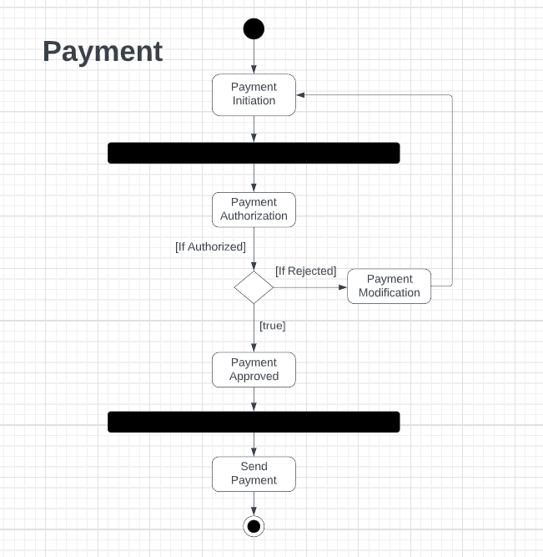

# SOFTWARE DEVELOPMENT LIFE CYCLE

## Process Model

* We are going to use waterfall model in our project.
* As we know the requirements are fixed in our project so that we can easily work with this model .as we know waterfall is for where all the requirements are fixed.
* We are working with a system where we know what is going to be we collect the requirements from the customers and then everything going to work .and for this types of prosses waterfall is the best choice .

## Project Role Identification and Responsibilities

* **Owner, project manager, tester, developer, customer**
* Owner: who give the Funding related things and give all kinds of financial support
* Project manager: who manage all the necessary needs and assigns the tasks to the worker.
* Tester: who test all the necessary tests of the systems .and make it sure that everything’s working perfectly and on the right positions.
* Customer gives the requirements to the project manager so that the work can start.

## Wire frames

## Testing Phase

|  |  |  |  |  |  |
| --- | --- | --- | --- | --- | --- |
| Project Name: Ukeel | | | Test Designed by: Md Salman | | |
| Test Case ID: U_k1 | | | Test Designed date: 22.07.2022 | | |
| Test Priority (Low, Medium, High): High | | | Test Executed by: Salman Hossain | | |
| Module Name: Login Session | | | Test Execution date: 23.07.2022 | | |
| Test Title: verify login with valid username and password | | | | | |
| Description: Test website login page | | | | | |
| Precondition (If any): User must have valid username and password | | | | | |
| Test Steps | Test Data | Expected Results | | Actual  Results | Status  (Pass/Fail) |
| 1. Go to the website 2. Enter username 3. Enter password 4. Click submit | Username:  1222222222  Password: 123 | User should login into the application | | As expected, | Pass |
| Post Condition: User is validated with database and successfully login to account. The account session details are logged in the database. | | | | | |

|  |  |  |  |  |  |
| --- | --- | --- | --- | --- | --- |
| Project Name: Ukeel | | | Test Designed by: Md Salman | | |
| Test Case ID: U_k2 | | | Test Designed date: 22.07.2022 | | |
| Test Priority (Low, Medium, High): low | | | Test Executed by: Salman Hossain | | |
| Module Name: Info Button | | | Test Execution date: 23.07.2022 | | |
| Test Title: Press and show the information about software | | | | | |
| Description: testing Info button | | | | | |
| Precondition (If any): Null | | | | | |
| Test Steps | Test Data | Expected Results | | Actual  Results | Status  (Pass/Fail) |
| 1. Go to the website 2. Press Info Button | Username:  1222222222  Password: 123 | User should see the page of information | | As expected, | Pass |
| Post Condition: User can see the desired information page. | | | | | |

|  |  |  |  |  |  |
| --- | --- | --- | --- | --- | --- |
| Project Name: Ukeel | | | Test Designed by: Sumit Chakraborty | | |
| Test Case ID: U_k3 | | | Test Designed date: 22.07.2022 | | |
| Test Priority (Low, Medium, High): High | | | Test Executed by: Md Salman | | |
| Module Name: Sign up Session | | | Test Execution date: 23.07.22 | | |
| Test Title: Sign up with email and password | | | | | |
| Description: Test website sign up page | | | | | |
| Precondition (If any): User must have valid username and password | | | | | |
| Test Steps | Test Data | Expected Results | | Actual  Results | Status  (Pass/Fail) |
| 1. Go to the website 2. Enter username 3. Enter password 4. Click submit | Username:  1222222222  Password: 123 | User should sign up into the application | | As expected, | Pass |
| Post Condition: User is validated with database and successfully registerd to account. The account session details are logged in the database. | | | | | |

````````````````````````````````````````````````````````````````````````````````````````````````````````````````````````````````

|  |  |  |  |  |  |
| --- | --- | --- | --- | --- | --- |
| Project Name: Ukeel | | | Test Designed by: Md Salman | | |
| Test Case ID: U_k4 | | | Test Designed date: 22.07.2022 | | |
| Test Priority (Low, Medium, High): High | | | Test Executed by: Sumit Chakraborty | | |
| Module Name: Search button | | | Test Execution date: 23.07.22 | | |
| Test Title: verify that the search button is working or not | | | | | |
| Description: Test search button | | | | | |
| Precondition (If any): Null | | | | | |
| Test Steps | Test Data | Expected Results | | Actual  Results | Status  (Pass/Fail) |
| 1. Go to the website 2. Click search button 3. Enter search queries 4. Click submit | Username:  1222222222  Password: 123 | User should able to search their desired queries. | | As expected, | Pass |
| Post Condition: User can search their desired queries. | | | | | |

```````````````````````````````

|  |  |  |  |  |  |
| --- | --- | --- | --- | --- | --- |
| Project Name: Ukeel | | | Test Designed by: Md Salman | | |
| Test Case ID: U_k5 | | | Test Designed date: 22.07.2022 | | |
| Test Priority (Low, Medium, High): Low | | | Test Executed by: Salman Hossain | | |
| Module Name: Subscription button | | | Test Execution date: 23.07.2022 | | |
| Test Title: Press and show subscription information | | | | | |
| Description: Testing subscription button | | | | | |
| Precondition (If any): Null | | | | | |
| Test Steps | Test Data | Expected Results | | Actual  Results | Status  (Pass/Fail) |
| 1. Go to the website 2. Press subscription button | Username:  1222222222  Password: 123 | User should see the page of subscription | | Not as expected, | Fail |
| Post Condition: User cannot see the desired subscription page. | | | | | |

```````````````````

|  |  |  |  |  |  |
| --- | --- | --- | --- | --- | --- |
| Project Name: Ukeel | | | Test Designed by: Md Salman | | |
| Test Case ID: U_k6 | | | Test Designed date: 22.07.2022 | | |
| Test Priority (Low, Medium, High): Medium | | | Test Executed by: Sumit Chakraborty | | |
| Module Name: Find Lawyer button | | | Test Execution date: 23.07.22 | | |
| Test Title: Press and show find lawyer page | | | | | |
| Description: Testing find lawyer button | | | | | |
| Precondition (If any): Null | | | | | |
| Test Steps | Test Data | Expected Results | | Actual  Results | Status  (Pass/Fail) |
| 1. Go to the website 2. Press find-lawyer button | Username:  1222222222  Password: 123 | User should see the page of find lawyer | | Not as expected, | Fail |
| Post Condition: User cannot see the desired find-lawyer page. | | | | | |

`````````````````````

|  |  |  |  |  |  |
| --- | --- | --- | --- | --- | --- |
| Project Name: Ukeel | | | Test Designed by: Sumit Chakraborty | | |
| Test Case ID: U_k7 | | | Test Designed date: 23.07.2022 | | |
| Test Priority (Low, Medium, High): Low | | | Test Executed by: Md Salman | | |
| Module Name: More button | | | Test Execution date: 24.07.22 | | |
| Test Title: Press and show more page | | | | | |
| Description: Testing more button | | | | | |
| Precondition (If any): Null | | | | | |
| Test Steps | Test Data | Expected Results | | Actual  Results | Status  (Pass/Fail) |
| 1. Go to the website 2. Press more button | Username:  1222222222  Password: 123 | User should see the page of more | | As expected, | Pass |
| Post Condition: User can see the desired more page. | | | | | |

`````````````````````

|  |  |  |  |  |  |
| --- | --- | --- | --- | --- | --- |
| Project Name: Ukeel | | | Test Designed by: Md Salman | | |
| Test Case ID: U_k8 | | | Test Designed date: 23.07.2022 | | |
| Test Priority (Low, Medium, High): Low | | | Test Executed by: Sumit Chakraborty | | |
| Module Name: Family law specialist button | | | Test Execution date: 24.07.22 | | |
| Test Title: Press and show family law specialist page | | | | | |
| Description: Testing family law specialist button | | | | | |
| Precondition (If any): Null | | | | | |
| Test Steps | Test Data | Expected Results | | Actual  Results | Status  (Pass/Fail) |
| 1. Go to the website 2. Press family law specialist button | Username:  1222222222  Password: 123 | User should see the page of family law specialist | | As expected, | Pass |
| Post Condition: User can see the desired family law specialist page. | | | | | |

`````````````````````

|  |  |  |  |  |  |
| --- | --- | --- | --- | --- | --- |
| Project Name: Ukeel | | | Test Designed by: Md Salman | | |
| Test Case ID: U_k9 | | | Test Designed date: 23.07.2022 | | |
| Test Priority (Low, Medium, High): Low | | | Test Executed by: Sumit Chakraborty | | |
| Module Name: Tax law specialist button | | | Test Execution date: 24.07.22 | | |
| Test Title: Press and show tax law specialist page | | | | | |
| Description: Testing tax law specialist button | | | | | |
| Precondition (If any): Null | | | | | |
| Test Steps | Test Data | Expected Results | | Actual  Results | Status  (Pass/Fail) |
| 1. Go to the website 2. Press tax law specialist button | Username:  1222222222  Password: 123 | User should see the page of tax law specialist | | Not as expected, | Fail |
| Post Condition: User cannot see the desired tax law specialist page. | | | | | |

`````````````````````

|  |  |  |  |  |  |
| --- | --- | --- | --- | --- | --- |
| Project Name: Ukeel | | | Test Designed by: Md Salman | | |
| Test Case ID: U_k10 | | | Test Designed date: 24.07.2022 | | |
| Test Priority (Low, Medium, High): Low | | | Test Executed by: Salman Hossain | | |
| Module Name: Criminal law specialist button | | | Test Execution date: 25.07.22 | | |
| Test Title: Press and show criminal law specialist page | | | | | |
| Description: Testing criminal law specialist button | | | | | |
| Precondition (If any): Null | | | | | |
| Test Steps | Test Data | Expected Results | | Actual  Results | Status  (Pass/Fail) |
| 1. Go to the website 2. Press criminal law specialist button | Username:  1222222222  Password: 123 | User should see the page of criminal law specialist | | As expected, | Pass |
| Post Condition: User can see the desired criminal law specialist page. | | | | | |

`````````````````````

|  |  |  |  |  |  |
| --- | --- | --- | --- | --- | --- |
| Project Name: Ukeel | | | Test Designed by: Md Salman | | |
| Test Case ID: U_k11 | | | Test Designed date: 24.07.2022 | | |
| Test Priority (Low, Medium, High): High | | | Test Executed by: Sumit Chakraborty | | |
| Module Name: Consult Session | | | Test Execution date: 25.07.2022 | | |
| Test Title: press and confirm a time slot for consultation | | | | | |
| Description: Test consult button | | | | | |
| Precondition (If any): User must have valid username and password | | | | | |
| Test Steps | Test Data | Expected Results | | Actual  Results | Status  (Pass/Fail) |
| 1. Go to the website 2. Search for desired lawyer 3. Click profile 4. Click consult button | Username:  1222222222  Password: 123 | User should able to book a time slot for consultation. | | As expected, | Pass |
| Post Condition: User is validated with database and successfully booked a time for consultation. This information is saved into the database. | | | | | |

|  |  |  |  |  |  |
| --- | --- | --- | --- | --- | --- |
| Project Name: Ukeel | | | Test Designed by: Sumit Chakraborty | | |
| Test Case ID: U_k12 | | | Test Designed date: 24.07.2022 | | |
| Test Priority (Low, Medium, High): High | | | Test Executed by: Sumit Chakraborty | | |
| Module Name: Payment Session | | | Test Execution date: 25.07.2022 | | |
| Test Title: press pay now button and confirm a payment | | | | | |
| Description: Test pay now button | | | | | |
| Precondition (If any): User must have valid username and password | | | | | |
| Test Steps | Test Data | Expected Results | | Actual  Results | Status  (Pass/Fail) |
| 1. Go to the website 2. Search for desired lawyer 3. Click profile 4. Click consult button 5. Click pay now button | Username:  1222222222  Password: 123 | User should able to pay the required fee. | | As expected, | Pass |
| Post Condition: User is validated with database and successfully paid the fee for consultation. This information is saved into the database. | | | | | |

|  |  |  |  |  |  |
| --- | --- | --- | --- | --- | --- |
| Project Name: Ukeel | | | Test Designed by: Md Salman | | |
| Test Case ID: U_k13 | | | Test Designed date: 24.07.2022 | | |
| Test Priority (Low, Medium, High): High | | | Test Executed by: Md Salman | | |
| Module Name: Lawyer registration Session | | | Test Execution date: 25.07.2022 | | |
| Test Title: register with email and password | | | | | |
| Description: Test lawyer register button | | | | | |
| Precondition (If any): User must have valid username and password | | | | | |
| Test Steps | Test Data | Expected Results | | Actual  Results | Status  (Pass/Fail) |
| 1. Go to the website 2. Click register button 3. Click lawyer register button 4. Enter username 5. Enter password 6. Enter NID 7. Click submit | Username:  1222222222  Password: 123 | User should sign up as a lawyer | | As expected, | Pass |
| Post Condition: User is validated with database and successfully sign up as a lawyer. This information is saved into the database. | | | | | |

|  |  |  |  |  |  |
| --- | --- | --- | --- | --- | --- |
| Project Name: Ukeel | | | Test Designed by: Sumit Chakraborty | | |
| Test Case ID: U_k14 | | | Test Designed date: 25.07.2022 | | |
| Test Priority (Low, Medium, High): Low | | | Test Executed by: Sumit Chakraborty | | |
| Module Name: Feature button | | | Test Execution date: 25.07.22 | | |
| Test Title: Press and show feature page | | | | | |
| Description: Testing feature button | | | | | |
| Precondition (If any): Null | | | | | |
| Test Steps | Test Data | Expected Results | | Actual  Results | Status  (Pass/Fail) |
| 1. Go to the website 2. Press feature button | Username:  1222222222  Password: 123 | User should see the page of feature | | Not as expected, | Fail |
| Post Condition: User cannot see the desired feature page. | | | | | |

`````````````````````

|  |  |  |  |  |  |
| --- | --- | --- | --- | --- | --- |
| Project Name: Ukeel | | | Test Designed by: Sumit Chakraborty | | |
| Test Case ID: U_k15 | | | Test Designed date: 25.07.2022 | | |
| Test Priority (Low, Medium, High): Low | | | Test Executed by: Sumit Chakraborty | | |
| Module Name: Contact us button | | | Test Execution date: 26.07.22 | | |
| Test Title: Press and show contact us page | | | | | |
| Description: Testing contact us button | | | | | |
| Precondition (If any): Null | | | | | |
| Test Steps | Test Data | Expected Results | | Actual  Results | Status  (Pass/Fail) |
| 1. Go to the website 2. Press contact-us button | Username:  1222222222  Password: 123 | User should see the page of contact us. | | As expected, | Pass |
| Post Condition: User can see the desired contact-us page. | | | | | |

`````````````````````

|  |  |  |  |  |  |
| --- | --- | --- | --- | --- | --- |
| Project Name: Ukeel | | | Test Designed by: Md Salman | | |
| Test Case ID: U_k16 | | | Test Designed date: 26.07.2022 | | |
| Test Priority (Low, Medium, High): Medium | | | Test Executed by: Salman Hossain | | |
| Module Name: Privacy policy button | | | Test Execution date: 27.07.22 | | |
| Test Title: Press and show privacy policy page | | | | | |
| Description: Testing privacy policy button | | | | | |
| Precondition (If any): Null | | | | | |
| Test Steps | Test Data | Expected Results | | Actual  Results | Status  (Pass/Fail) |
| 1. Go to the website 2. Press privacy policy button | Username:  1222222222  Password: 123 | User should see the page of privacy policy. | | As expected, | Pass |
| Post Condition: User can see the desired privacy policy page. | | | | | |

`````````````````````

## WBS Table

## Estimations Based on COCOMO Model :

|  |  |  |  |
| --- | --- | --- | --- |
| Organic | **Coefficient**= 2.4 | P=1.05 | T = 0.38 |

**PM :** person-months needed for project (labor working hours)  
**SLOC :** source lines of code  
**P :** project complexity (1.04-1.24)  
**DM :** duration time in months for project (week days)  
**T :** SLOC-dependent coefficient (0.32-0.38)  
**ST :** average staffing necessary

* **Effort = PM = Coefficient<Effort Factor>*(SLOC/1000)^P**

**= = 41.23**

[100,000 SLOC/1000 = 100k SLOC]

* **Development time = DM = 2.50*(PM)^T**

**= = 10.252**

* **Required number of people = ST = PM/DM**

**==3.9921**